LOCATION BASED REMINDER: A WIZARD
Sunayana
Sunayana.prakash@gmail.com
Swati Purushottam
swatipurushottam26@gmail.com
Arpana Kulkarni

arpana.kulkarni14@gmail.com

“LOCATION BASED REMINDER” is an application which reminds oneself of something based on where one is, unlike setting reminders based on the time of the day. This application lets one set GPS based notification on his/her smart phone. Location wizard allows to set up a new note, attach it to a location (by address or by GPS auto-location), and set the notification. You can have it notified when you enter or exit a certain radius of the location, too, making the notifications much more reliable.
This application also allows to bookmark locations. One can bookmark certain places and find the various paths between any two bookmarked locations and also specifies the total distance. It helps to search a particular place or a landmark.

Keywords— Android, LBS, GPS, Google Maps.

- INTRODUCTION

Android is an operating system for mobile devices such as smart phones and tablet computers. Android consists of a kernel base the Linux kernel, with middleware, libraries and APIs written in C and application software running on an application framework which includes Java-compatible libraries.

As the technology is emerging rapidly, smart phones are one of such products that provide the latest utility based applications. We are developing one of such application which uses Google Maps and GPS to set reminders based on the location.

“LOCATION WIZARD” is an application which reminds oneself of something based on where one is, unlike setting reminders based on the time of the day. This application lets one set GPS based notification on his/her smart phone. Location wizard allows to set up a new note, attach it to a location (by address or by GPS auto-location), and set the notification. You can have it notified when you enter or exit a certain radius of the location, too, making the notifications much more reliable.
This application also allows to bookmark locations. One can bookmark certain places and find the various paths between any two bookmarked locations and also specifies the total distance. It helps to search a particular place or a landmark.
1.2 Purpose of project
The main goal of location based reminders is to help people remind about something based on the location. The application aims at setting a GPS based notification on a smart phone. This notification will be notified to the user when he/she enters or exits a certain radius of the intended location.

1.1 Objective of location based services
We have proposed an application which consists of 4 modules:-
1. Mapping the places.
2. Bookmarking the places.
3. Finds the distance between two places.
4. Location based reminder.

- PROPOSED METHODS
2.1 Existing Method:
The present scenario is such that the reminders are set based on the time and date. Where in one will be notified about something at particular time on particular day.
2.2 Proposed Method:
“LOCATION WIZARD” is an application which reminds oneself of something based on where one is, unlike setting reminders based on the time of the day. This application lets one set GPS based notification on his/her smart phone. Location wizard allows to set up a new note, attach it to a location (by address or by GPS auto-location), and set the notification. You can have it notified when you enter or exit a certain radius of the location, too, making the notifications much more reliable.

- RELATED WORK
The idea of using location information in context-aware applications is not new. Much work has been done in the past in context-aware prototypes that have all shown location to be a useful element of context. The Forget-me-not project was one of the pioneering efforts in the area of context aware reminders. Forget-me-not employs a small PDA-like device that associates different items of interest with icons to help the person remember various tasks they need to attend to. Commotion is a more recent example of a context-
Aware system supporting reminders that utilize location as contextual information. Using GPS technology for location-sensing, people could set reminders around certain locations, with given time constraints. When the person was near that location and the timing constraints were satisfied, they would be alerted with an audio alert.Cybreminder took these ideas a step further, developing a reminder application based on the Context Toolkit [8] that focused on using a variety of context information, including location, to determine when best to trigger reminders. This project focused on abstracting hardware technology away from the developer. Thus, it was able to create a fully featured reminders application taking into account a variety of contextual information. This toolkit relies on the existence of special sensing hardware that limits its ability to be deployed ubiquitously. Focusing on a different aspect of reminders, Stick-e notes [5] explored the post-it metaphor in the digital rather than physical world. Stick-e notes were placed at particular locations using GPS enabled PDAs, and could be made visible to others, thus emulating the affordances of physical notes in a digital environment. Unlike the previously mentioned systems, Active Campus examines mobile computing restricted to a university campus setting and provides a location-based reminders system using 802.11 radios to provide location sensing. A reminders feature is integrated into the system where people can set reminders to be triggered at predefined locations on campus, typically buildings. The wearable computing research community has also had a number of projects exploring reminder notifications through extra hardware. Memo clip uses a small wearable computer that relies on location beacons distributed in the environment to trigger location-based reminders [4]. The reminder bracelet involves a bracelet worn on the wrist of the user that subtly alerts the wearer of upcoming events, as entered into their PDA calendar, using temporal information only [11]. The Sulaweski framework discusses a spatial reminder service that uses GPS and infrared to approximate a person’s location and delivers reminders accordingly [20]. Memory glasses is another project that attempts to augment user memory by using subliminal cues [6]. The wearable remembrance agent used a heads up display to provide context-relevant information [21]. While some of these systems use implicit reminders, with some type of context or activity inferencing, they all find that subtle cues are effective. Like the systems mentioned above, these wearable solutions also focus on exploring new services that can be provided using location as context. In the ethnographic space, Kaasinen performed a study examining people’s needs for location-based services, using existing tools and methods.
- IMPLEMENTATION OF LOCATION WIZARD
Our application Location Wizard mainly consists of 4 modules:
1. Set reminders: Helps one to set a reminder for intended location.
2. Bookmark places: Helps one to bookmark a location of interest and save that to the bookmark list.
3. Search nearby: Helps one to search nearby location and also find distance between two locations
4. Where am I? : Helps the user to locate himself.

The figure below shows the overall system design for location wizard.

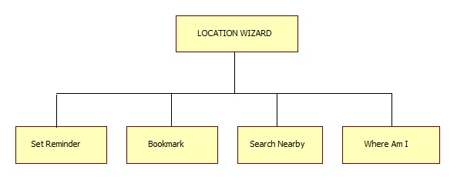
Fig 2.1 System design for location wizard
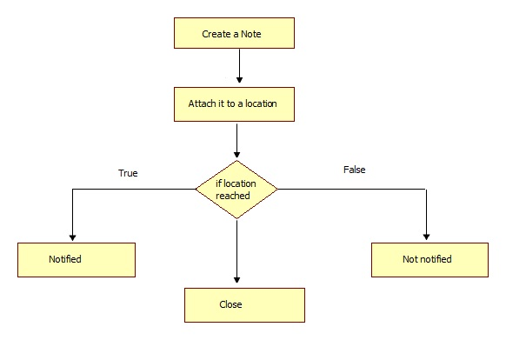

Fig 2.2 System design for location based reminder

4. APPLICATIONS OF LOCATION WIZARD
1. Mapping on to Google Map.
2. Bookmark places of interest.
3. Location based reminder.
4. Searching nearby bookmarks.
5. Finding the path between two bookmarked places along with total distance

5. CHALLENGES OF LOCATION WIZARD

1. Works only on Android based smart phones.
2. Does not work without any Internet connection.
3. Consumes more battery power.

6. FUTURE SCOPE
After going through the surveying, it can be gathered that there is a huge scope of application development in mobile domain. Following the same notion, we can also develop application that can tackle following issues
1) Location positioning technologies
2) Query processing
3) Cache management
Applications can be developed on Android platform of Open Handset Alliance led by Google. Google provides simulated environment and standard development kit for developing Android applications. Although this platform is very new and SDK provided is still in its nascent stage, a great number of mobile companies are queuing up to install it on their devices. We chose Android as it is parallel to iOS (supported by Apple) in terms of facilities it provide and is also open source. The LBS application can help user to find hospitals, school, gas filling station or any other facility of interest indicated by user within certain range. Just like a GPS device its location will also be updated as soon as user changes his/her position.
9. CONCLUSION
Initially mobile phones were developed only for voice communication but now days the scenario has changed, voice communication is just one aspect of a mobile phone. There are other aspects which are major focus of interest. Two such major factors are web browser and GPS services. Both of these functionalities are already implemented but are only in the hands of manufacturers not in the hands of users because of proprietary issues, the system does not allow the user to access the mobile hardware directly. But now, after the release of android based open source mobile phone a user can access the hardware directly and design customized native applications to develop Web and GPS enabled services and can program the other hardware components like camera etc.
The LBS application can help user to find hospitals, school, gas filling station or any other facility of interest indicated by user within certain range. Just like a GPS device its location will also be updated as soon as user changes his/her position.

Acknowledgment
We express my sincere thanks to Head of the Department, Information Science and Engineering, for their kind co-operation for presenting the paper. I also extend my sincere thanks to all other members of the faculty of Information Science and Engineering Department and my friends for their co-operation and encouragement.

REFERENCES
[1] Dey, A.K. and Abowd, G. D. CybreMinder: A Context-Aware System for Supporting Reminders. Intl. Symposium on Handheld and Ubiquitous Computing, pp. 172-186.(2000)
[2].D'Roza, T., and Bilchev, G. An overview of location-based services. BT Technology Journal 21, 1 (2003),20_27
[3] DeVaul, R. W., Pentland, A., Corey, V. R. The Memory Glasses: Subliminal vs. Overt memory Support with Imperfect Information. IEEE International Symposium on Wearable Computers.
[4] Beigl, M. MemoClip: A Location-Based Remembrance Appliance. Personal and Ubiquitous Computing 4(4), pp. 230-233.

